**Assignment -1**

Python Programming

|  |  |
| --- | --- |
| Assignment Date | 19 September 2022 |
| Student Name | Mr. P G HARI PRASAD |
| Student Roll Number | 113219071011 |
| Maximum Marks | 2 Marks |

**Question-1:**

**1. Split this string**

|  |
| --- |
| **Solution:** |
| s **=** "Hi there Sam!"  print(s.split()) |

**Question-2:**

## 2. Use .format() to print the following string.

### Output should be: The diameter of Earth is 12742 kilometers.

|  |
| --- |
| **Solution:** |

planet **=** "Earth"

diameter **=** 12742

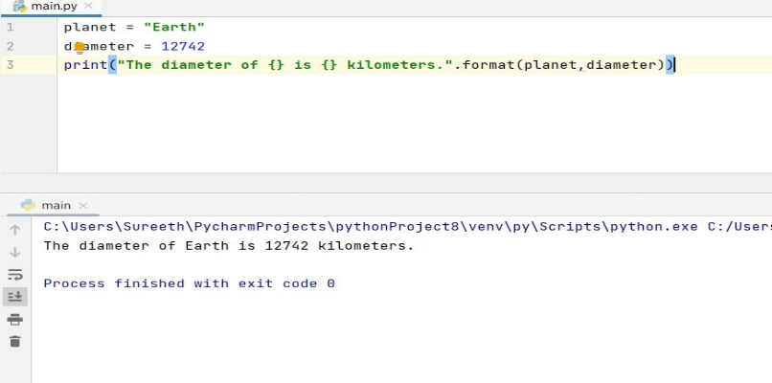 print("The diameter of {} is {} kilometers. "**.**format(planet,diameter))

## 3. In this nest dictionary grab the word "hello"

## Solution:

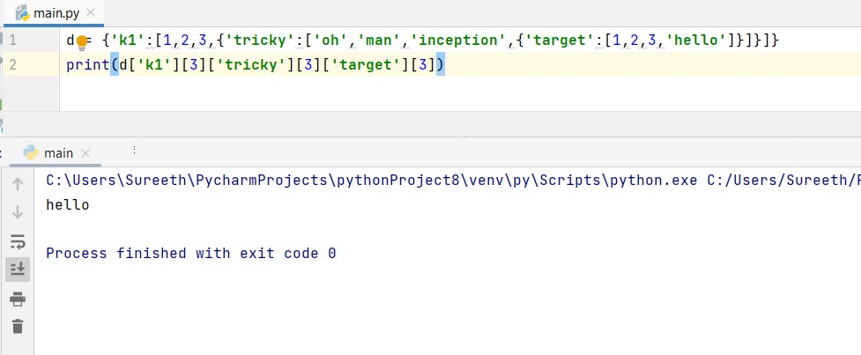d={**'k1'**:[1,2,3,{**'tricky'**:[**'oh'**,**'man'**,**'inception'**,{**'target'**:[1,2,3,**'hello'**]}]}]}

print(d[**'k1'**][3][**'tricky'**][3][**'target'**][3])

## 4.1 Create an array of 10 zeros?

## Solution:

**import** numpy **as** np

array = np.zeros(10)

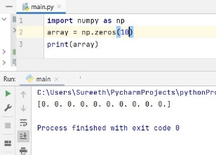print(array)

## 4.2 Create an array of 10 fives?

## Solution:

Import numpy as np

array = np.ones(10)*5

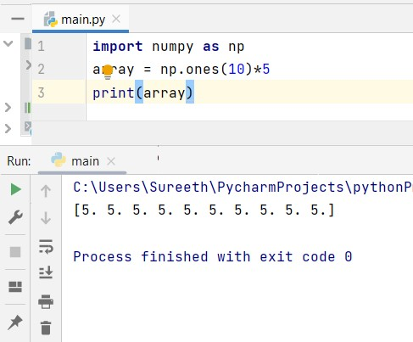print(array)

## 5. Create an array of all the even integers from 20 to 35

## Solution:

Import numpy as np

array = np.arange(20,35,2)

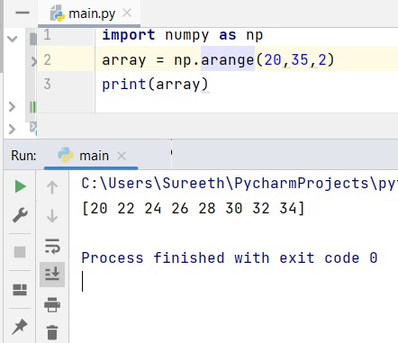print(array)

## 6. Create a 3x3 matrix with values ranging from 0 to 8

## Solution:

import numpy as np

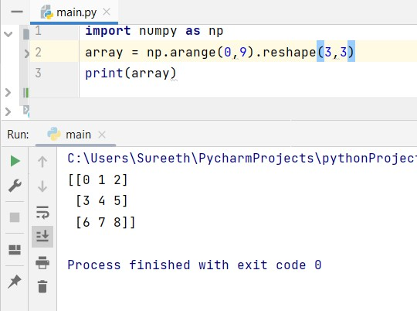array = np.arange(0,9).reshape(3,3)

print(array)

## 7. Concatinate a and b

## a = np.array([1, 2, 3]), b = np.array([4, 5, 6])

## Solution:

import numpy as np

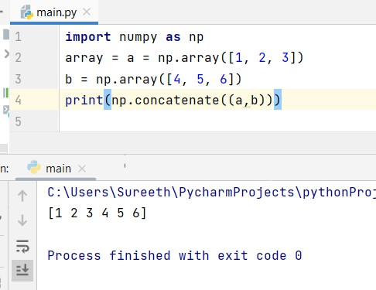array = a = np.array([1,2,3])

b = np.array([4,5,6])

print(np.concatenate((a,b)))

## 8. Create a dataframe with 3 rows and 2 columns

## Solution:

import pandas as pd

data **=** {'col_1': [2,1,5],

'col_2': [3,4,8],

}

df**=**pd**.**DataFrame(data)

print(df)

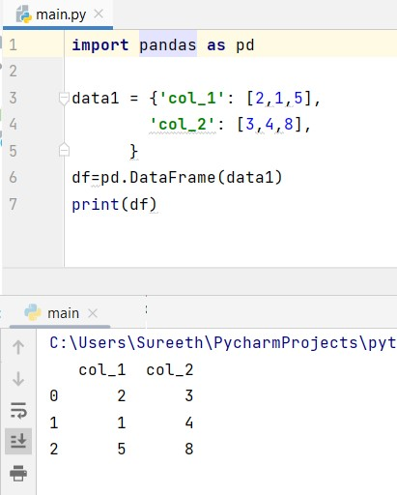

## 9. Generate the series of dates from 1st Jan, 2023 to 10th Feb, 2023

## Solution:

import pandas as pd

date**=**pd**.**date_range(start**=**'01.01.2023',end**=**'10.02.2023')

print(date)

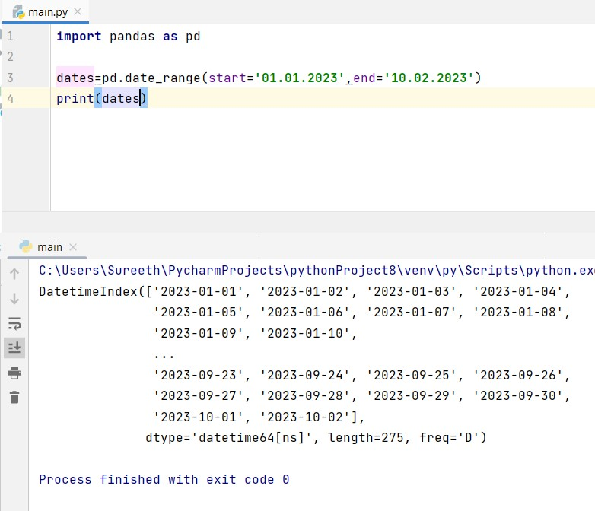

## 10. Create 2D list to DataFrame

lists = [[1, 'aaa', 22], [2, 'bbb', 25], [3, 'ccc', 24]]

## Solution:

import pandas as pd

lists **=** [[1, 'aaa', 22], [2, 'bbb', 25], [3, 'ccc', 24]]

df **=** pd**.**DataFrame(lists)

print(df)

